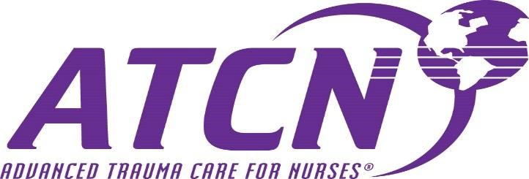
Full/Closed- April 22/23, 2021- Full Two Day Course from 0730-1730 on both days.

______ June 9, 2021- Renewal Class/One Day from 0800-1630 (must submit copy of current ATCN card).

_____ July 19, 2021- Hybrid One Day Course from 0800-1730 (course requires completion of online ATLS Modules and a full day of ATCN teaching stations and testing. Recommended that participants are experienced trauma providers.

_____ November 5/6, 2021- Full Two Day Course from 0730-1730 on both days.

Where: | Fee:
Memorial Hospital of South Bend  615 N. Michigan Street  South Bend, IN 46601 | $275.00 (Non Beacon Associates)
Make checks payable to: Memorial Hospital Trauma Services
Please mail check and registration form to: Attn Stacie Bobeck
Memorial Hospital South Bend: Trauma Services
615 N. Michigan St. South Bend, IN 46601
574-647-2853 sbobeck@beaconhealthsystem.org
Beacon Associates who register in Net Learning MUST still complete the Registration Form Choose a date and complete the following information: PRINT
Name____________________________________________________
Address____________________________________________________
City________________________ State__________ Zip code________
Preferred Email ___________________________________________
Phone__________________________________________
Place Employment_____________________________ Dept.________
___Fee Enclosed _____Employer Sending Fee

